CERTIFICATION
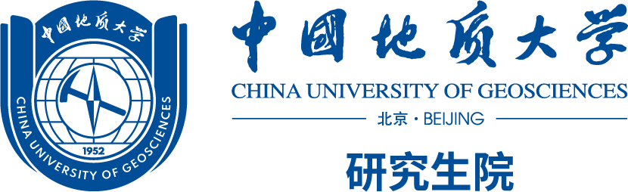
No. 29 Xueyuan Road, Haidian District Beijing 100083 P.R. China
Tel: 86-10-82322062
This is to certify that Mr./Miss (姓名), male/female, born on (出生日期，年月日), Student ID XXXXXXX, is a full-time registered student of the Five-year Combined Master/Doctor Program, majoring in (专业) in the （学院） in China University of Geosciences (Beijing), and that his/her duration of study in this university is from (硕士入学时间，月，年) to （博士正常毕业时间月，年） (He/She was a postgraduate student from (硕士入学时间，月，年) to (硕士结束时间，月，年). From（博士开始时间，月，年） to（博士正常毕业时间月，年）, he/she studies in the phase of Ph.D. student. ).
This is also to certify that students on the above program are awarded ONE Doctor Degree of the related field of study upon the satisfaction of relevant requirements, instead of a master’s degree and a Doctor degree after each phase of study.
Your kind assistance to his/her application is highly appreciated.
Thank you for your kind attention.

Graduate School of China University of Geosciences (Beijing)
2024-12-8

